Translated from: https://blog.gerardmaudrux.lequotidiendumedecin.fr/2021/01/07/covid-19-actualites/

THE MISSING COUNCIL!

After the Defense Council, the Health Advisers of the President, the Prime Minister, the Ministry of Health, Social Security Directorate, General Directorate of Health, Public Health France and its directorates (dir. "Alert and crisis" , dir. "prevention and health promotion", dir. "infectious diseases", dir. "environmental health" ...), the National Center for Scientific Research in Molecular Virology, the National Agency for Health Safety and its platform Epidemiology and Surveillance, the National Medicines Safety Agency, the High Authority for Health, Regional Health Agencies, the National Health Insurance Fund and Primary Funds, I certainly forget, and after the Covid Scientific Council- 19 created in March and the "Guidance Council of the vaccine strategy" created at the beginning of December and chaired by Alain Fischer here is Macron’s latest brain child: the "Citizens Council for vaccination", overseen by the Economic Social and Environmental Council. Now be surprised that it does not work. (FYI, the organizational chart of one of these organizations, with all its directorates and sub-directorates: https://blog.gerardmaudrux.lequotidiendumedecin.fr/wp-content/uploads/2021/01/Organigramme_ARS-Est.pdf )

35 citizens drawn at random, who will be scientifically trained to give advice to those who only listen to themselves. But what fraudster invented this? Which President validated it? The crisis deserves something other than some absurd media-focused politics.

As all these fine people are not yet sufficient (or too incompetent), the government has appealed to the American management consulting firm McKinsey (https://actu.orange.fr/politique/vaccins-l-etat-fait-appel-au-cabinet-americain-mckinsey-tolle-dans-l-opposition-magic-CNT000001w5dj9.html ). This firm is "attached to the vaccination task force of the Ministry of Health, and collaborates on strategy and logistics". Question: what’s the use of all this administration and all these frauds which cost us very very dearly? 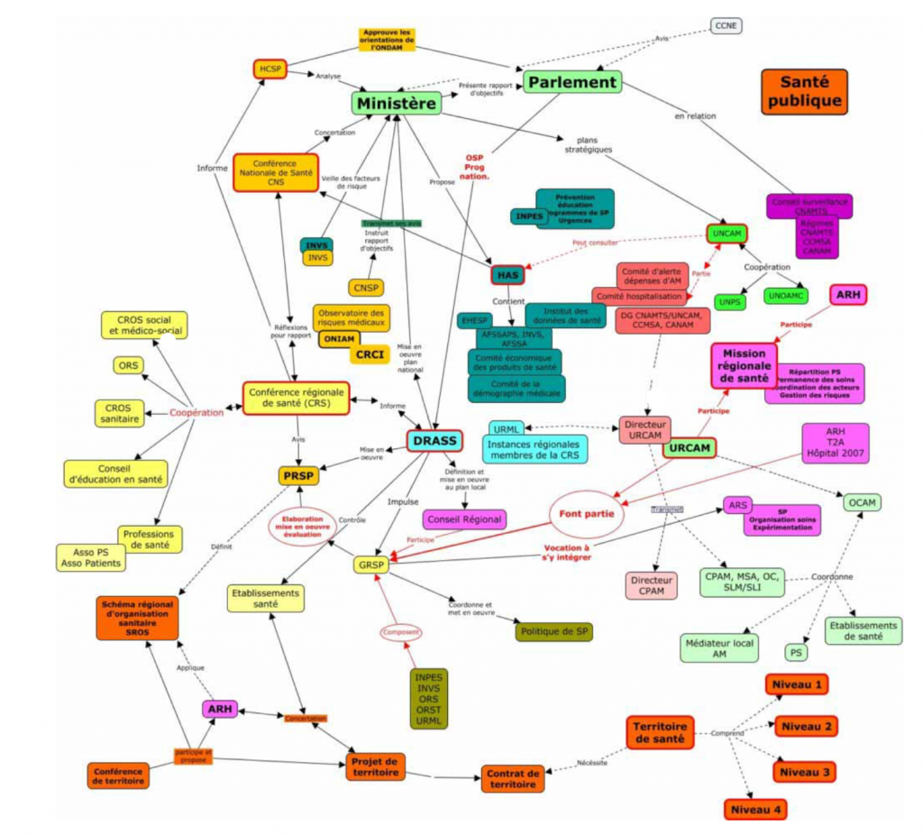

origin : https://infobruche.fr/lorganisation-de-la-sante-en-france/

VACCINE SHORTAGE

A month after the "Council for the Vaccine Strategy" announced that the logistics were ready ( https://www.hospimedia.fr/actualite/articles/20201203-politique-de-sante-un-conseil-d-orientation-de ), following an outcry in the press, and in political and medical circles for a few days, France being ranked hundredth in the world for the number vaccinated, and following the emergency meeting at the Elysee Palace on January 4th, on the morning of the 5th, our brilliant minister announces measures to face the crisis and reassure everyone ( https://www.rtl.fr/actu/politique/coronavirus-veran-annonce-l-elargissement-des-vaccins-aux-pompiers-et-aides-a-domicile-7800950377 ): the vaccination will be extended to firefighters over 50 years old and home helpers! Phew, we feel better!

VACCINE SHORTAGE

Why is France lagging behind despite being "ready for months" and having the most extensive administration in the world? On Monday, I am told (I cannot verify), that we are having the same problems as we had for the first masks: when we do not pay, that we quibble over prices, urgent deliveries go elsewhere, especially in Israel (more of a million vaccinated) who maybe paid 40% more (to be verified, but prices are State secrets). The next morning, I heard Xavier Bertrand asking "for transparency to be made on the number of vaccines actually delivered ( https://www.europe1.fr/politique/vaccination-macron-a-commis-une-faute-gravissime-estime-xavier-bertrand-4016300 )", seeming to confirm this rumor: the problem is not in dispatching, but at the source. We will know the truth one day thanks to parliamentary inquiries.

IVERMECTIN

My favorite treatment for 8 months is slowly making its way. More and more publications in its favor, all showing an improvement, except one, French of course, from Lyon.

American doctors invited to come and speak to the Senate, the WHO is interested in it, appointing a specialist, Dr Andrew Hill from the Department of Pharmacology at the University of Liverpool to conduct a review and meta-analysis ( https://translate.google.com/translate?hl=fr&sl=en&u=https://trialsitenews.com/unitaid-part-of-the-world-health-organization-funding-ivermectin-research-targeting-covid-19-led-by-british-expert/&prev=search&pto=aue ) which gives the opposite results ( https://www.youtube.com/watch?v=yOAh7GtvcOs&feature=youtu.be ) of the Lyonnaise study:

Out of 44 studies with 7,100 patients, it treated only the randomized studies involving 1,456 patients. Significant decrease in viral load, hospital stay almost halved, and mortality divided by 5. These are only hospitalized patients, we know that these results are even better amongst outpatients and as a form of preventive healthcare, confirming effectiveness at all stages. Results without appeal. The WHO now wants to wait for three more trials, which are expected to be published in January, before issuing an official recommendation. We are waiting impatiently.

The icing on the cake, we are starting to talk about it in the mainstream press (not yet the French medical and scientific press): Paris Match (yes!) 9 https://www.parismatch.com/Actu/Sante/Covid-19-l-ivermectine-une-piste-a-suivre-1719386 ) , The Times ( https://www.thetimes.co.uk/article/ivermectin-tests-show-cheap-drug-may-reduce-covid-19-death-toll-zb27lx8wt ) , The Daily Mail ( https://www.dailymail.co.uk/news/article-9110301/Cheap-hair-lice-drug-cut-risk-hospitalised-Covid-patients-dying-80-study-finds.html ) , and Professor Raoult in his latest video ( https://www.mediterranee-infection.com/soin-mutants-vaccin/ ).

OTHER TREATMENTS

Unlike our authorities who do not look at anything not wanting to find a cure for Covid, you know that I look at everything and always ask that we test everything that is reported.

Do you know black seed (nigella sativa)? It is "black cumin", a spice widely used by Muslims, and a medicinal plant in Babylon and ancient Egypt, also praised by Hippocrates. "It cures all ills except death" wrote Ibn Qayyim al-Jawziyya. Well imagine, it could be a cure for Covid too!

A serious study, from Pakistan, 4 centers, randomized, 313 patients, 210 moderate, 103 severe, combining honey and black seed versus placebo. Spectacular results ( https://www.medrxiv.org/content/10.1101/2020.10.30.20217364v4 ): symptoms disappear twice as fast, mortality divided by 4, the same results as Ivermectin cited by Hill !!. Here is a very complete publication on Nigella ( https://www.ncbi.nlm.nih.gov/pmc/articles/PMC7347483/ ) and mode of action.

We should perhaps resume the work of the sixties on Thymoquinone, one of the active ingredients of black seed, work on its anti-oxidant, anti-inflammatory (superior to the classic Indomethacin), antihistamine and active (shown in vitro and in vitro) against certain germs. Let’s not forget that the finest nuggets in our pharmacopoeia come from plants.

It's crazy how we look abroad, we test everything to find a cure. De Gaulle complained about our researchers who found nothing; now we know why: it's because we aren't looking.

DANGEROUS VACCINE?

It seems that it is not just the genetic risk overlooked by the precautionary principle with respect to new vaccines. Another risk seems to emerge.

Have you heard of the ADE phenomenon ( https://video.wakkeren.nl/videos/watch/9bd9f602-e5e9-47e0-b35d-8f1bfd78f0f4 ) (antibody dependent enhancement), which would lead to pulmonary immunopathology several months after mRNA vaccination? This is not a made-up issue against the current vaccination, as it’s referred to in an article from 2012 ( https://journals.plos.org/plosone/article/figure?id=10.1371/journal.pone.0035421.g003 ) (click "back to article" to get it all).

One of the vaccines tested for SARS-Cov-1 caused a kind of pulmonary autoimmune disease with eosinophil infiltration in mice, not found in the control group. Conclusion of the article: "These SARS-CoV vaccines all induced antibodies and protection against SARS-CoV infection. However, the cohort of mice that received one of the vaccines led to the development of Th2-type immunopathology suggesting that hypersensitivity to the components of SARS-CoV was induced. Caution is advised when applying a SARS-CoV vaccine to humans. "
It seems that Dr Fauci had spoken about it at the beginning of research on vaccines, saying, in mentioning this risk, that one had to wait 12-18 months before vaccinating ( https://www.youtube.com/watch?v=nbEUhxZzQ0k ) . It seems that everyone has forgotten this.

With regard to these mRNA and DNA vaccines, let's be clear: this can be a fantastic revolution, the treatment of tomorrow for a lot of diseases, but today we don't know the long term effects. So experiment, yes, but you don't experiment on 500 million people without having any certainty about possible long-term effects.

VACCINE MUTANTS?

The variant that is problematic today is named N501Y, and is located in the RNA of the virus, modifying the spike protein, making entry into human cells easier. It has been present mainly in England, as well as in South Africa, but also in Brazil, since April. These 3 countries feel that they are out of control today. We may well follow.

AstraZeneca's vaccine has undergone phase 3 trials with 4 teams: 2 in England, 1 in South Africa, 1 in Brazil, which officially started on April 23 (and since August 31 in the USA). This vaccine is a so-called DNA vaccine, injecting one or more genetically modified adenoviruses (non-pathogenic viruses responsible for “flu-like syndromes”) into which DNA sequences of SARS-Cov-2 are introduced. On the other hand, the risk of integration of DNA vaccines is not zero, not requiring transcriptase as for RNA, which cannot integrate into DNA without this enzyme. Switching from DNA (from vaccine) to RNA (from virus) is possible, switching from RNA to DNA is not possible without transcriptase.

Can SARS-Cov-2 vaccine + infection produce a mutant by DNA mixing? However, viruses mutate on their own without necessarily having to be in a relationship, but coupling does help to produce babies, and the coincidence is disturbing. We should look into the problem and get the answer quickly.

AFTER SEASONAL INFLUENZA, SEASONAL COVID?

With its multiple mutations, with its immunity that seems less durable than what we would have liked, we are increasingly talking about a disease similar to seasonal flu, which makes our leaders and specialists increasingly say that we might have to live with it for a while. We even offer vaccination 3 to 6 months after having had the disease.

If this is confirmed, as with the flu, there’s no point in mass vaccination , only those at risk need it as with the seasonal one. For others, it must be treated on a case-by-case basis; treatments seem to exist to avoid severe forms - I hope we will admit it one day, it will come. In these conditions, we should perhaps review the strategy of the whole vaccine programme and stop blocking the search for other alternatives; we are not going to vaccinate 3 times a year, including those who are unlikely to be sick, to reduce contagiousness.

With regard to this contagiousness, the tests and measures developed, it might also be necessary to adapt to the latest advances, such as the fact that the majority of positives are not contagious, only those who are symptomatic are contagious. Is this finding from 10 million people ( https://www.francesoir.fr/opinions-tribunes/les-bien-portants-dits-asymptomatiques-ne-transmettent-pas-le-covid19-etude ) not sufficient for our specialists?

HIS MAJESTY

In the Republic it is the people and their representatives who decide, this is no longer the case with us. 4000 medals for the new year, never seen before. Who decides ? There was a time when the King distributed land, but France is no longer what it was, the King is reduced to distributing what yesterday was called the rattles of the Republic, and which must now be called the King’s charms. It is no longer for services rendered to the Republic, but for those who please His Majesty. For those who don't like it, luckily times have changed, this is no longer the dungeon, and I'm very happy for Professor Juvin. A scandal ( https://actu.orange.fr/france/matignon-a-propose-la-legion-d-honneur-au-professeur-philippe-juvin-avant-de-faire-volte-face-magic-CNT000001w3YTa.html ).

